**Technocrats Electrical Vacation Task-1**

**Multimeter different modes and its functionality**

A basic Digital Multimeter works with electrical circuits and measures alternating current (AC), AC voltage, direct current (DC), DC voltage, resistance, continuity and diodes

## Using a Multimeter - Measuring Functions on the Instrument

A basic multimeter facilitates the measurement of the following quantities:

* DC voltage
* DC current
* AC voltage
* Resistance
* Continuity - indicated by a buzzer or tone

Some basic meters don't have an AC current range.

In addition meters may have the following functions:

* Capacitance measurement
* Transistor HFE or DC current gain
* Temperature with an additional probe
* Diode test
* Frequency

Voltage, current and resistance ranges are usually set by turning a rotary selection dial, and the measurement is indicated on an LCD display or scale. Laboratory bench DMMs sometimes have seven segment LED displays.

## Voltage, Current and Resistance Ranges

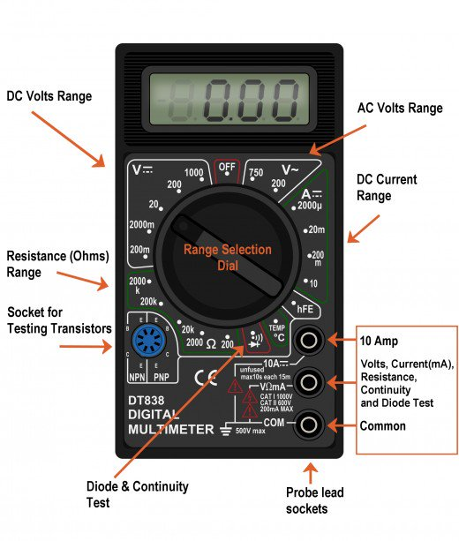

## How to Measure Voltage

1. Power off the circuity/wiring under test if there is a danger of shorting out closely spaced adjacent wires, terminals or other points which have differing voltages
2. Plug the black ground probe lead into the COM socket on the meter (see photo below)
3. Plug the red positive probe lead into the socket marked V (usually also marked with the Greek letter "omega" Ω and possibly a diode symbol)
4. If the meter has has a manual range setting dial, turn this to select AC or DC volts and pick a range to give the required accuracy. So for instance measuring 12 volts on the 20 volt range will give more decimal places than on the 200 volt range.  
   If the meter is autoranging, turn the dial to the 'V' setting with the symbol for AC or DC (see "What Do the Symbols on the Range Dial Mean?" below)
5. A multimeter must be connected in parallel in a circuit (see diagram below) in order to measure voltage. So this means the two test probes should be connected in parallel with the voltage source, load or any other two points across which voltage needs to be measured.
6. Touch the black probe against the first point of the circuitry/wiring
7. Power up the equipment
8. Touch the other red probe against the second point of test. Ensure you don't bridge the gap between the point being tested and adjacent wiring, terminals or tracks on a PCB
9. Take the reading on the LCD display

## How to Measure Current

1. Turn off the power in the circuit being measured
2. A multimeter must be inserted in series with the load in a circuit in order to measure current.  
   Plug the ground probe lead into the COM socket and plug the red positive probe lead either into the mA socket or the high current socket which is usually marked 10A (some meters have a 20 A socket instead of 10A). The mA socket is often marked with the maximum current and if you estimate that the current will be greater than this value, you must use the 10 A socket, otherwise you will end up blowing a fuse in the meter
3. Connect the meter in series as in the diagram below
4. Turn the dial on the meter to the highest current range (or the 10A range if the probe is in the 10A socket). If the meter is autoranging, set it to the "A" or mA setting. (See the photo above for an explanation of symbols used).
5. Turn on the power
6. If the range is too high, you can switch to a lower range to get a more accurate reading
7. Remember to return the positive probe to the V socket when finished measuring current. The meter is practically a short circuit when the lead is in the mA or 10 A socket. If you forget and connect the meter to a voltage source when the lead is in this position, you may end up blowing a fuse at best or blowing up the meter at worst! (On some meters the 10A range is un-fused)

## How to Measure Resistance

1. Turn off all power to the circuit being measured
2. Disconnect one end of the resistance from the circuit. This may involve pulling off spade leads or desoldering a component. This is important as there may be other resistances in parallel with the resistance being measured
3. The probes are connected to the meter in the same way as for measuring voltage
4. Turn the dial to the lowest Ohm or Ω range. This is likely to be the 200 ohm range or similar
5. Place a probe tip at each end of the resistance being measured
6. If the display indicates "I", this means that resistance is greater than can be displayed on the range setting you have selected, so you must turn the dial to the next highest range. Repeat this until a value is displayed on the LCD

## How to Check Continuity and Fuses

A multimeter is useful for checking breaks in flexes of appliances, blown filaments in bulbs and blown fuses, and tracing paths/tracks on PCBs

1. Turn the selecting dial on the meter to the continuity range. This is often indicated by a symbol which looks like a series of arcs of a circle (See the photo showing symbols used on meters above)
2. The probe leads are connected to the meter in the same way as for measuring voltage
3. If a conductor on a circuit board/ a wire in an appliance needs to be checked, make sure the device is powered down
4. Place the tip of a probe at each end of the conductor or fuse which needs to be checked
5. If resistance is less than about 30 ohms, the meter will indicate this by by a beep tone or buzzing sound. The resistance is usually indicated on the display also. If there is break in continuity in the device being tested, an overload indication, usually the digit "1", will be displayed on the meter.

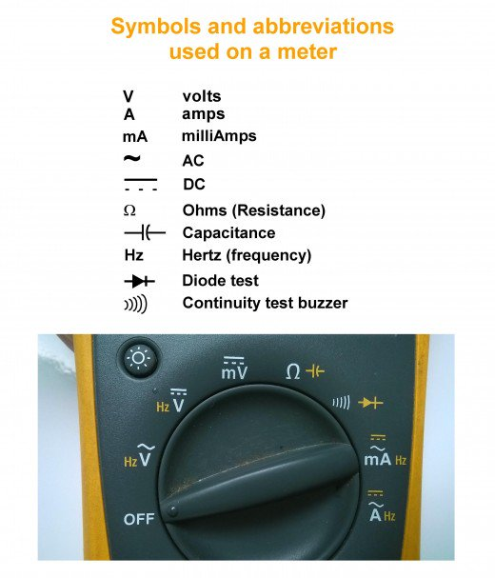

## How to Check Diodes

A multimeter can be used to check whether a diode is short circuited or open circuited. A diode is an electronic one way valve or check valve, which only conducts in one direction. A multimeter when connected to a working diode indicates the voltage across the component.

1. Turn the dial of the meter to the diode test setting, which is indicated by a triangle with a bar at the end (see the photo showing symbols used on meters above)
2. The probes are connected to the meter in the same way as for measuring voltage
3. Touch the tip of the negative probe to one end of the diode, and the tip of the positive probe to the other end
4. When the black probe is in contact with the cathode of the diode (usually indicated by a bar marked on the component) and the red probe makes contact with the anode, the diode conducts, and the meter indicates the voltage. This should be about 0.6 volts for a silicon diode and about 0.2 volts for a Schottky diode. When the probes are reversed, the meter should indicate a "1" because the diode is open circuit and non-conducting.
5. If the meter reads "1" when the probes are placed either way, the diode is likely to be faulty and open circuit. If the meter indicates a value close to zero, the diode is shorted circuited.
6. If a component is in circuit, resistances in parallel will affect the reading and the meter may not indicate "1" but a value somewhat less

**Some Important Take Aways**

**Measuring current:**

**Basically, there will be two ports for measuring the current in the multimeter.**

**mA – This will have a fuse 200mA**

**20A – no fuse**

**Resolution** refers to how fine a measurement a meter can make. By knowing the resolution of a meter you can determine if it is possible to see a small change in the measured signal. The terms digits and counts are used to describe a meter’s resolution. DMMs are grouped by the number of counts or digits they display. A 3 ½-digit meter can display three full digits ranging from 0-9 and one half digit which displays only a “1” or is left blank. A 3 ½ digit meter will display up to 1,999 counts of resolution and a 4 ½ digit meter can display up to 19,999 counts of resolution. Some DMMs may have enhanced resolution offering higher counts within their digit range.

Checking continuity

* Keep in that wifi symbol thing
* Touch probe together
* Beeps working fine, no beep there is a problem
* Its also applicable for electronic devices.
* In non ceramic capacitor, if it doesn’t beep it’s a good one
* This will tell if there is a short or break in the wire too.

Discharging a capacitor : connect the two terminals of the capacitor to the same probe or connect the two capacitor legs together

For electrolytic capacitor: for electrolytic capacitor of higher value we cant measure, to check if its working. We ll set the multimeter to the ohmic range and we ll first connect the red to –ve of the capacitor and black to the +ve side of the capacitor. It slowly charges . again we reverse the probes and check it. It will recharge again in opposite direction. If it doesn’t, its not working. If dischares its an ac capacitor

**Different types of switches**

Types of Switches

[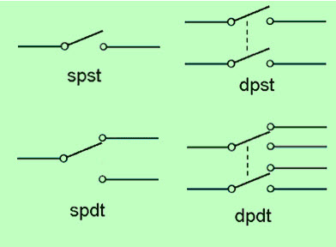](http://efxkits.com/blog/wp-content/uploads/2015/07/Types-of-Switches.jpg)

SPST (Single Pole Single Through)

The SPST is a basic ON/OFF switch, that is used to connect or break the connection between two terminals. The power supply for the owl circuit is given by this switch. A simple PST switch is shown below.

The application of SPST switch is light switch and it is also called as a toggle switch. This type of switch has one input and one output. This light switch circuit controls one wire and makes one connection. This is an ON/OFF switch, when the switch is ON or closed, then the current flows through the two terminals and the bulb in the circuit will blink. When the switch is OFF or open, then the current doesn’t flow through the two terminals.

REED Switch is also a perfect example of SPST

[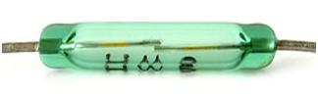](https://www.elprocus.com/wp-content/uploads/2013/07/Reed-Switch.jpg)Reed Switch

SPDT (Single Pole Double Throw)

The SPDT switch is a three terminal switch, one terminal is used as input and remaining two terminals are used as outputs. It joins a mutual terminal to one or the other of two terminals.In the SPDT switch, instead of other terminals, just use COM terminal. For example, we can use COM & A or COM & B.

Example of an SPDT switch

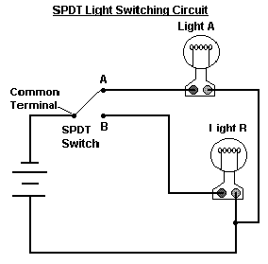

DPST (Double Pole, Single Throw)

The DPST switch consists of two poles that means it includes two identical switches located on side by side. This switch is operated by one single toggle, which means that two discrete circuits are controlled at a time through one push.

DPDT (Double Pole Double Throw)

This switch is equal to two SPDT switches, it means two separate circuits, connecting two inputs of each circuit to one of two outputs. The switch position controls the number of ways and from the two contacts each contact can be routed.

DPDT Relay is a perfect example

DPDT relay can be used to power one device/appliance or another. While SPDT relay can only switch the output circuit between on and off states; a DPDT relay can also be used to change the polarity at the terminals of a device connected at output. For example, to drive a DC motor in both clockwise and anticlockwise directions, following connections can be done. Pins 2 & 7 can be provided with Vcc (9V for motor) and ground, respectively. The first motor terminal can be connected to pins 3 & 4 while the other terminal to pins 5 & 6. In case no input signal is given, the motor would rotate in one direction (say clockwise, depending upon the connection of its terminals). When an input signal is provided, the contactors change their positions, resulting in the anticlockwise rotation of motor.

Pin Diagram:

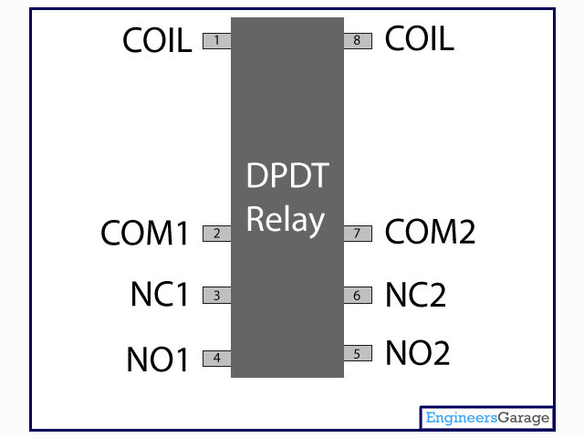

**Step up and Step Down converters and substitutes**

The buck boost converter is a DC to DC converter. The output voltage of the DC to DC converter is less than or greater than the input voltage. The output voltage of the magnitude depends on the duty cycle. These converters are also known as the step up and step down transformers and these names are coming from the analogous step up and step down transformer. The input voltages are step up/down to some level of more than or less than the input voltage. By using the low conversion energy, the input power is equal to the output power. The following expression shows the low of a conversion.

Input power (Pin) = Output power (Pout)

For the step up mode, the input voltage is less than the output voltage (Vin < Vout). It shows that the output current is less than the input current. Hence the buck booster is a step up mode.

Vin < Vout and Iin > Iout

In the step down mode the input voltage is greater than the output voltage (Vin > Vout). It follows that the output current is greater the input current. Hence the buck boost converter is a step down mode.

Vin > Vout and Iin < Iout

## What is a Buck Boost Converter?

It is a type of DC to DC converter and it has a magnitude of output voltage. It may be more or less than equal to the input voltage magnitude. The buck boost converter is equal to the fly back circuit and single inductor is used in the place of the transformer. There are two types of converters in the buck boost converter that are buck converter and the other one is boost converter. These converters can produce the range of output voltage than the input voltage. The following diagram shows the basic buck boost converter.

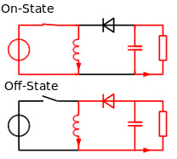Buck Boost Converter

### Working principle of Buck Boost Converter

The working operation of the DC to DC converter is the inductor in the input resistance has the unexpected variation in the input current. If the switch is ON then the inductor feed the energy from the input and it stores the energy of magnetic energy. If the switch is closed it discharges the energy. The output circuit of the capacitor is assumed as high sufficient than the time constant of an RC circuit is high on the output stage. The huge time constant is compared with the switching period and make sure that the steady state is a constant output voltage Vo(t) = Vo(constant) and present at the load terminal.

There are two different types of working principles in the buck boost converter.

* Buck converter.
* Boost converter.

### Buck Converter Working

The following diagram shows the working operation of the buck converter. In the buck converter first transistor is turned ON and second transistor is switched OFF due to high square wave frequency. If the gate terminal of the first transistor is more than the current pass through the magnetic field, charging C, and it supplies the load. The D1 is the Schottky diode and it is turned OFF due to the positive voltage to the cathode.

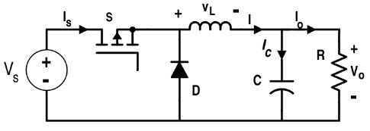Buck Converter Working

The inductor L is the initial source of current. If the first transistor is OFF by using the control unit then the current flow in the buck operation. The magnetic field of the inductor is collapsed and the back e.m.f is generated collapsing field turn around the polarity of the voltage across the inductor. The current flows in the diode D2, the load and the D1 diode will be turned ON.

The discharge of the inductor L decreases with the help of the current. During the first transistor is in one state the charge of the accumulator in the capacitor. The current flows through the load and during the off period keeping Vout reasonably. Hence it keeps the minimum ripple amplitude and Vout closes to the value of Vs

### Boost Converter Working

In this converter the first transistor is switched ON continually and for the second transistor the square wave of high frequency is applied to the gate terminal. The second transistor is in conducting when the on state and the input current flow from the inductor L through the second transistor. The negative terminal charging up the magnetic field around the inductor. The D2 diode cannot conduct because the anode is on the potential ground by highly conducting the second transistor.

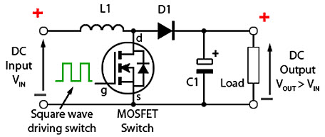Boost Converter Working

By charging the capacitor C the load is applied to the entire circuit in the ON State and it can construct earlier oscillator cycles. During the ON period the capacitor C can discharge regularly and the amount of high ripple frequency on the output voltage. The approximate potential difference is given by the equation below.